Results for species with significant effect on ALIEN richness

maudbv

6 August 2015

require(knitr)

## Loading required package: knitr

## Warning: package 'knitr' was built under R version 3.1.3

if( length(grep('mac', .Platform$pkgType) ) == 0){  
knitr::opts_knit$set( root.dir = "C:/Users/bernarm2/Dropbox/Work/doc boulot/post doc Lincoln/R_alienimpactBP")  
}  
  
 if( length(grep('mac', .Platform$pkgType) ) == 1) {  
knitr::opts_knit$set( root.dir = "~/Dropbox/Work/doc boulot/post doc Lincoln/R_alienimpactBP")  
 }  
  
knitr::opts_chunk$set( echo = FALSE, warning=FALSE)  
# packages  
library(doBy)

## Loading required package: survival

## Warning: package 'survival' was built under R version 3.1.3

## Numerical results

We study 88 focal species.

### trends in NATIVE alpha effect size for 10 species:

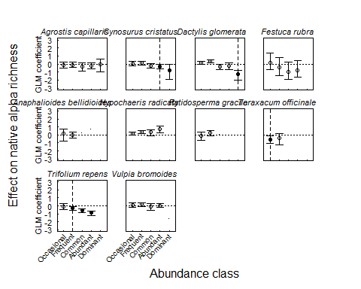

### trends in ALIEN alpha effect size for 10 species:

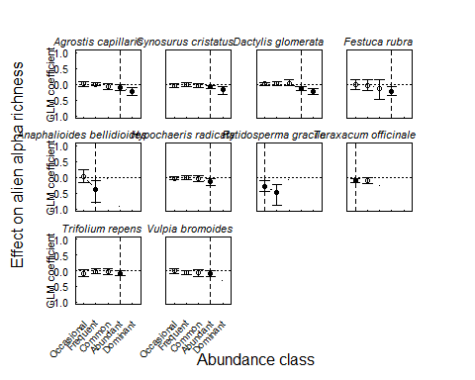

### trends in NATIVE gamma effect size for 10 species:

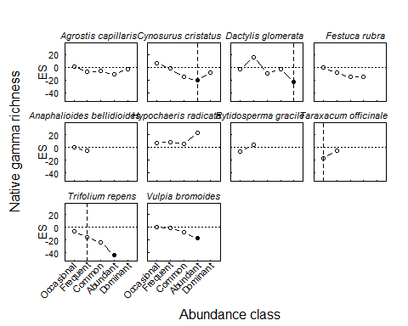

### trends in ALIEN gamma effect size for 10 species:

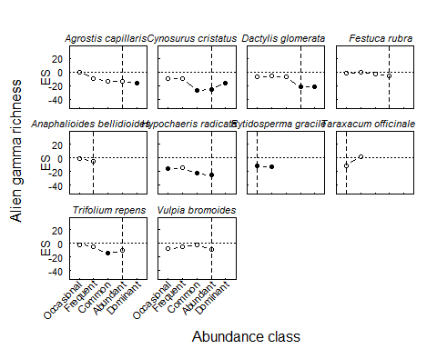

### Trends in NATIVE gamma above vs.below trends

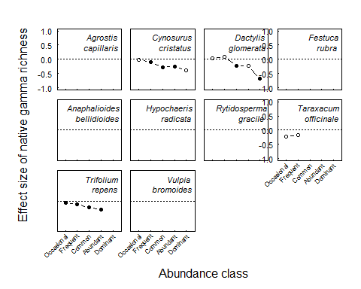

### Trends in ALIEN gamma above vs.below trends

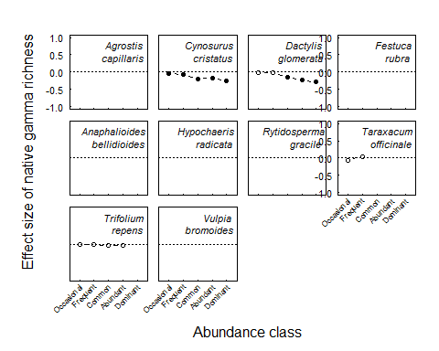

### Change in gamma frequency above/below critical threshold on native richness

